Immaculate Conception Church
91-1298 Renton Rd.
Ewa Beach, HI 96706
Ph#: (808) 681-3701
Fax#: (808) 681-3117
Fr. Nick Brown
Email: iccewa@rcchawaii.org
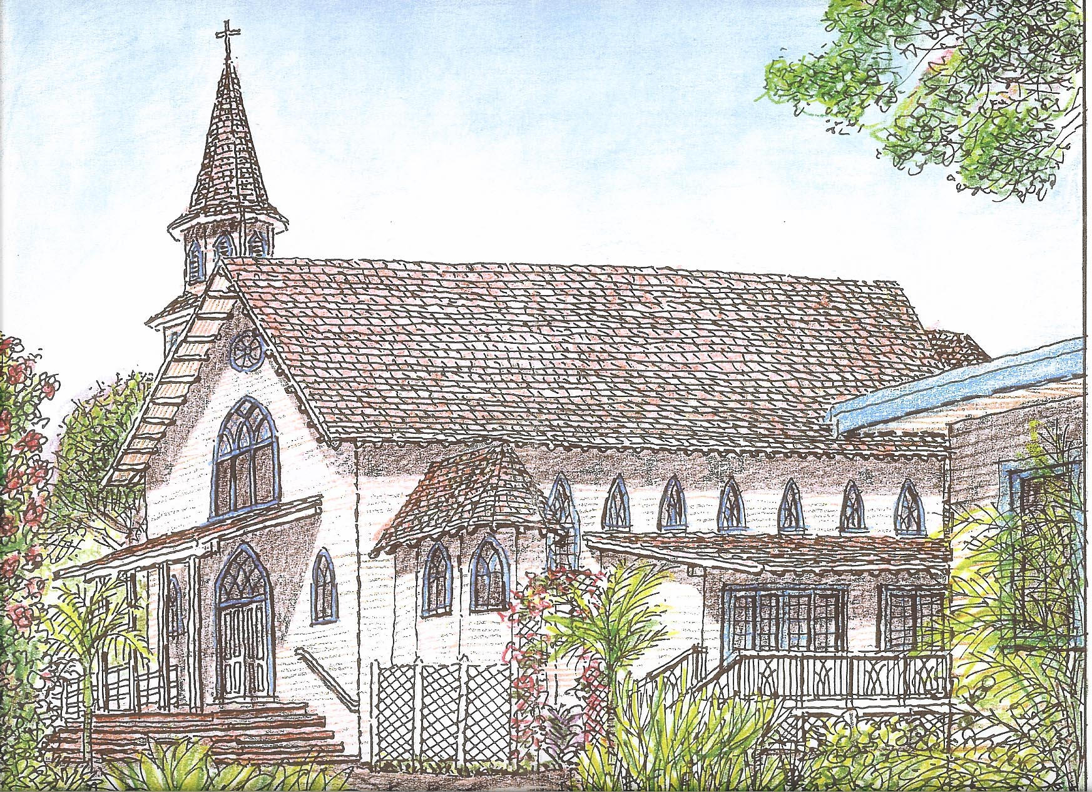

HOUSE BLESSING REQUEST

I am/We are registered parishioners of Immaculate Conception Church in Ewa.

Check one: Yes If yes, what is your registration number?

No

Not Sure

Person requesting House Blessing:
(Please print clearly):

House Address:

Telephone Contact: 808- - Alternate No#: : 808- -

Preference Date: (Please indicate a time and day that you would prefer Fr. to bless your house. Include alternative dates. Father will check his schedule to see if he can accommodate you. If he cannot, we will call to arrange a date.)

Reason for Blessing: (Select one)

New Home/Just moving in.

Extension/Additions to existing home.

Other reason. Please explain:

Father or Deacon will contact you for the date of the Blessing. There is to be no blessing of a house unless those who are to live in it are:

- Practicing Catholics
- Members of Immaculate Conception Parish
- In good standing with the Catholic Church

Please sign (or initial if sending via email): Date: / /2020

06/6/2014 iccewa\documents\parish\houseblessingrequest

HOUSE BLESSING DRIVING DIRECTIONS

From Renton:

Fort Weaver:

Next….
(Onto street name)
Take
Take
Take
Take
Take
Take
Take

Notes: (Opt., Description of house, e.g. color, distinguishing feature, etc. and any other pertinent information.)

